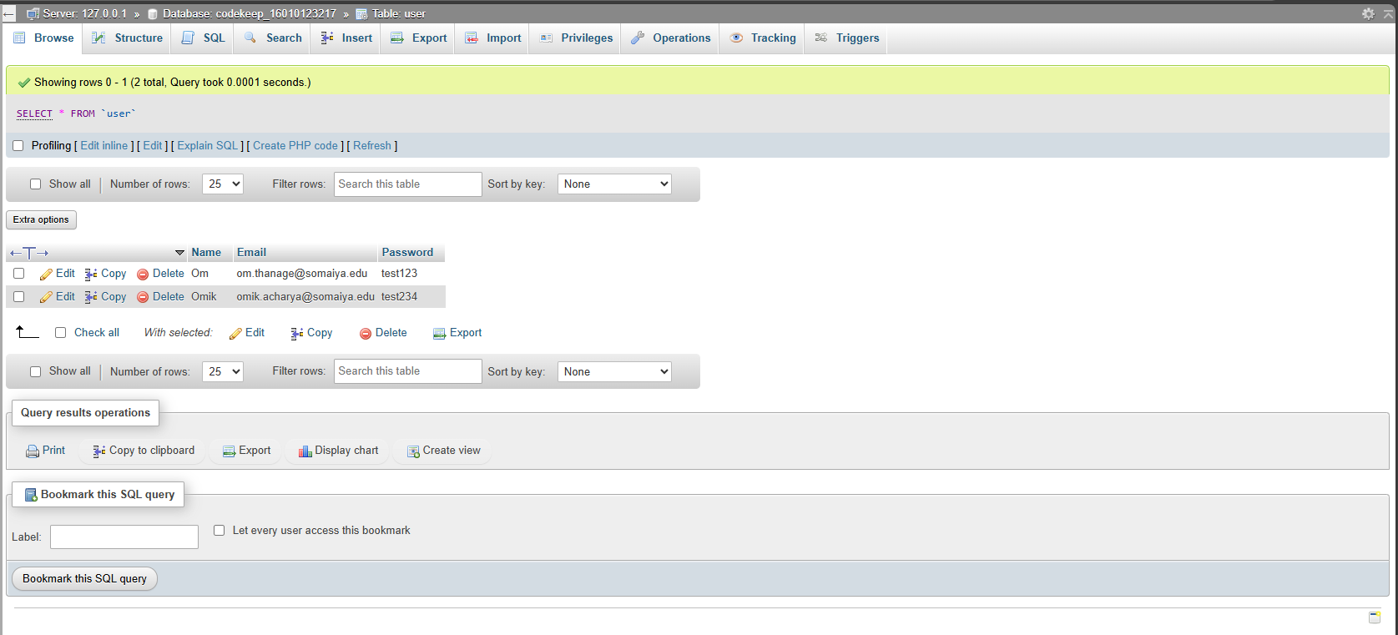

JS implemented  
<!DOCTYPE html>

<html lang="en">

<head>

    <meta charset="UTF-8">

    <meta name="viewport" content="width=device-width, initial-scale=1.0">

    <title>Document</title>

</head>

<body>

    <h1>Name: Om Thanage</h1>

    <h1>Roll No: 16010123217</h1>

    <div style="display: flex; gap: 4rem; align-items: center; justify-content: space-between; width: 50vw;">

        <h1>A)</h1>

        <h1>Display Date</h1>

        <p id="date"></p>

        <button style="padding: 12px;" onclick="displayDate()">Get Date</button>

    </div>

    <div style="display: flex; gap: 4rem; align-items: center;  justify-content: space-between; width: 50vw;">

        <h1>B)</h1>

        <h1>Factorial</h1>

        <button style="padding: 12px;" onclick="getFactorial()">Get Factorial</button>

    </div>

    <div style="display: flex; gap: 4rem; align-items: center;  justify-content: space-between; width: 50vw;">

        <h1>C)</h1>

        <h1>Multiplication Table</h1>

        <button style="padding: 12px;" onclick="getTable()">Get Table</button>

    </div>

    <div style="width: 50vw; margin-top: 2rem;" id="table"></div>

    </div>

    <script>

        function displayDate() {

            let date = new Date();

            document.getElementById("date").innerHTML = date;

        }

        function getFactorial() {

            let num = prompt("Enter a number: ");

            let factorial = 1;

            for (let i = 1; i <= num; i++) {

                factorial \*= i;

            }

            alert(`Factorial of ${num} is ${factorial}`);

        }

        function getTable() {

            let num = prompt("Enter a number: ");

            let table = "";

            for (let i = 1; i <= 10; i++) {

                table += `${num} x ${i} = ${num \* i}<br>`;

            }

            document.getElementById("table").innerHTML = table;

        }

    </script>

</body>

</html>

Output:  
